ENERGY WASTE: A DEEP DIVE INTO ENVIRONMENTAL CONSEQUENCES

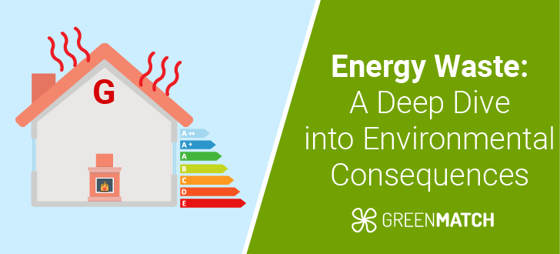

Energy waste contributes significantly to greenhouse gas emissions. In the United Kingdom, **approximately 62% of the energy generated is rejected,** meaning it is not used effectively and contributes to **unnecessary carbon dioxide (CO2) and methane emissions.** This inefficiency exacerbates global warming and [climate change](https://www.greenmatch.co.uk/blog/facts-about-climate-change), leading to severe weather events, rising sea levels, and biodiversity loss​.

A study by the [**International Energy Agency (IEA)**](https://www.iea.org/)found **that 66% of all global energy production is wasted.**This inefficiency translates directly into environmental harm.

This glimpse into the **consequences of energy waste paves the way for a deeper dive into solutions.** Understanding the impact on our environment helps us recognise the urgency of adopting more sustainable practices.

What Do We Mean By Energy Waste**?**

Energy waste, also **known as energy wastage or wasted energy, occurs when electricity or other forms of power are used unnecessarily or inefficiently.**This can happen in various environments, from **offices where lights remain on after everyone has left to factories with equipment** that leaks energy even when not in active use.

Understanding what constitutes energy waste is crucial for identifying and implementing [**effective energy-saving strategies**](https://www.greenmatch.co.uk/blog/2020/03/how-to-save-energy-at-home).

COMMON EXAMPLES OF ENERGY WASTE

1. **Office Spaces:** Lights and electronic devices are often left running overnight or during unoccupied hours, consuming electricity without providing any benefits.
2. **Industrial Settings:**Factories might experience significant energy loss due to outdated equipment or poor maintenance, such as leaky pipes or inefficient machinery.
3. **Standby Consumption:** Many devices continue to draw power even when not used actively. This "phantom" energy use can accumulate significant costs over time.

| **Region** | **Daily Waste Generation (kg/person)** | **Waste Management Efficiency (%)** | **Greenhouse Gas Emissions (MTCO2e)** |
| --- | --- | --- | --- |
| High-Income Countries | 4.54 | 90 | 1,100 |
| Middle-Income Countries | 0.74 | 57 | 900 |
| Low-Income Countries | 0.11 | 26 | 500 |

Reducing energy waste helps lower [**greenhouse gas emissions**](https://www.greenmatch.co.uk/blog/greenhouse-gases-statistics) and cuts down on utility bills. Burning [**fossil fuels**](https://www.greenmatch.co.uk/fossil-fuel-analysis) to generate **wasted energy releases greenhouse gases like carbon dioxide (CO₂) into the atmosphere, exacerbating global warming**. Additionally, the extraction and processing of energy resources often lead to habitat destruction, air and water pollution, and the depletion of natural resources.

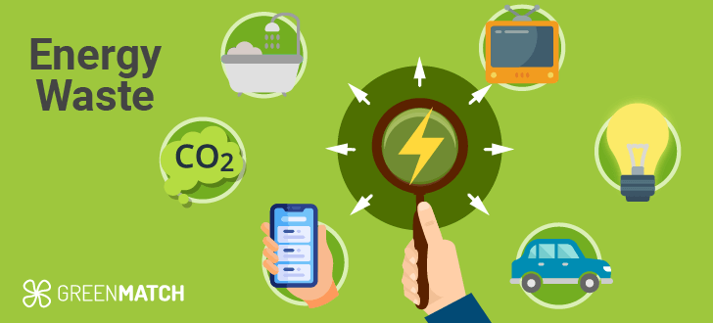

**CAUSES OF ENERGY WASTE**

Energy waste stems from various factors, including:

1. **Inefficient appliances and equipment:**Outdated or poorly maintained devices consume more energy than necessary.
2. **Poor insulation and air leaks:**Inadequate building insulation leads to excessive heating or cooling requirements.
3. **Lack of energy-efficient practices:** Leaving lights, electronics, and HVAC systems running when unnecessary wastes energy.
4. **Inefficient transportation:** Vehicles with low fuel efficiency and excessive idling contribute to energy waste.
5. **Industrial processes:** Outdated manufacturing methods and equipment can be energy-intensive.

| **Region** | **Energy Consumption (TWh)** | **Energy Wasted (%)** | **Energy Waste (% of Total Energy Consumption)** | **CO2 Emissions (Mt)** | **Key Environmental Impact** |
| --- | --- | --- | --- | --- | --- |
| North America | 12,000 | 66.7 | 22% | 5,000 | Air pollution, greenhouse gases |
| Europe | 7,500 | 60.0 | 18% | 3,200 | Air and water pollution |
| Asia | 20,000 | 70.0 | 27% | 10,500 | Deforestation, air pollution |
| Global Average | 50,000 | 65.0 | 24% | 30,000 | Climate change, resource depletion |

**ENVIRONMENTAL IMPACT OF ENERGY WASTE**

Wasting energy exacerbates climate change and depletes non-renewable resources. Fossil fuels used for energy production emit greenhouse gases like CO2 and methane. Methane is **28 times more effective at trapping heat than CO2**, intensifying global warming​.

Additionally, wasted energy means resources like **water, minerals, and land used for energy production get exploited unnecessarily.** Extracting and processing these resources can cause habitat destruction, water pollution, and biodiversity loss.

Generating excess energy requires burning more **fossil fuels like coal, oil, and natural gas, which release carbon dioxide (CO2), methane, and other pollutants** into the atmosphere. This exacerbates global warming and its devastating effects.